AI Assisted Coding
Lab-6.3
2303A51624
Batch – 08

Lab 6: AI-Based Code Completion – Classes, Loops, and Conditionals
Week: 3
Day: Wednesday

Lab Objectives
- To explore AI-powered code completion for Python classes, loops, and conditionals.
- To understand how AI suggests object-oriented and control-flow logic.
- To evaluate AI-generated code for correctness, readability, and completeness.

Lab Outcomes
After completing this lab, students will be able to:
- Generate Python classes and methods using AI tools.
- Analyze loop logic suggested by AI.
- Evaluate conditional statements generated by AI.
- Critically assess AI-assisted Python code.

Task Description #1: Classes (Student Class)
Scenario
Develop a simple student information management module.

AI-Generated Python Code
class Student:
def __init__(self, name, roll_number, branch):
self.name = name
self.roll_number = roll_number
self.branch = branch

def display_details(self):
print("Student Name:", self.name)
print("Roll Number:", self.roll_number)
print("Branch:", self.branch)

# Object creation
student1 = Student("Preetham", 101, "CSE")
student1.display_details()
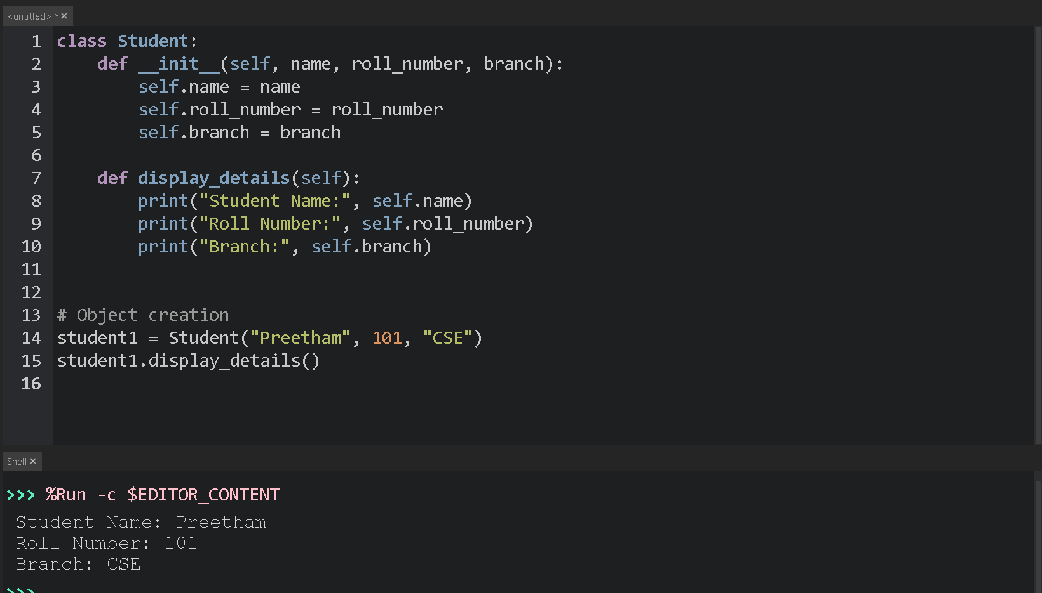

Output
Student Name: Preetham
Roll Number: 101
Branch: CSE

Analysis of AI-Generated Code
- The AI correctly created a class with a constructor (__init__).
- Attributes are clearly named and easy to understand.
- The display_details() method neatly prints student information.
- Code is readable, correct, and well-structured.
Conclusion: AI-generated code is accurate and suitable for beginner-level programs.

Task Description #2: Loops (Multiples of a Number)
Scenario
Display the first 10 multiples of a given number.

Using a for Loop
def print_multiples(num):
for i in range(1, 11):
print(num * i)

print_multiples(5)
Output
5
10
15
20
25
30
35
40
45
50

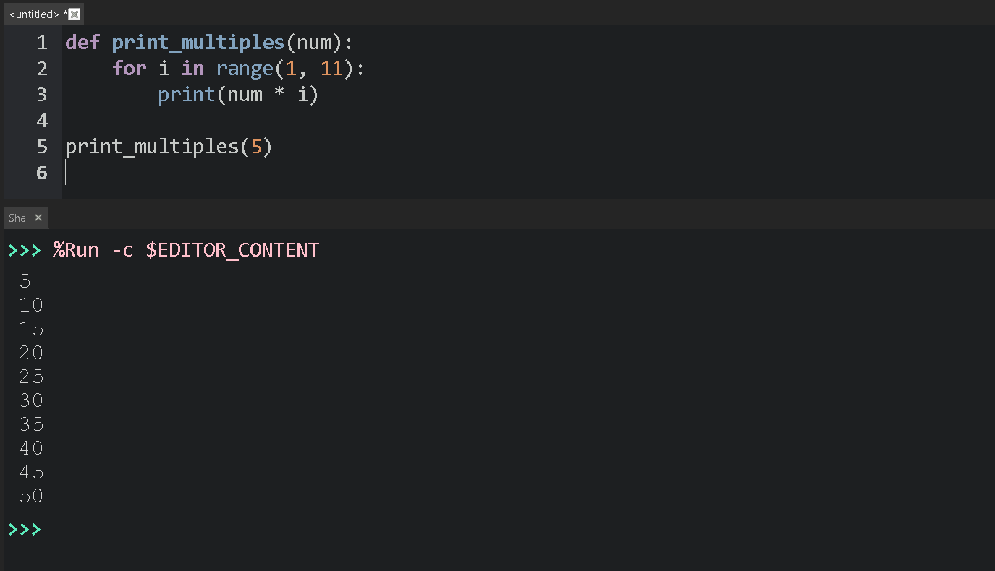
Using a while Loop
def print_multiples_while(num):
i = 1
while i <= 10:
print(num * i)
i += 1

print_multiples_while(5)

Comparison & Analysis
Feature | for Loop | while Loop
Readability | High | Medium
Best Use | Fixed iterations | Condition-based
Complexity | Simple | Slightly more
Both approaches work correctly, but the for loop is more concise.

Task Description #3: Conditional Statements (Age Classification)
Scenario
Classify people based on age.

Using Nested if-elif-else
def classify_age(age):
if age < 13:
return "Child"
elif age < 20:
return "Teenager"
elif age < 60:
return "Adult"
else:
return "Senior"

print(classify_age(25))
Output
Adult
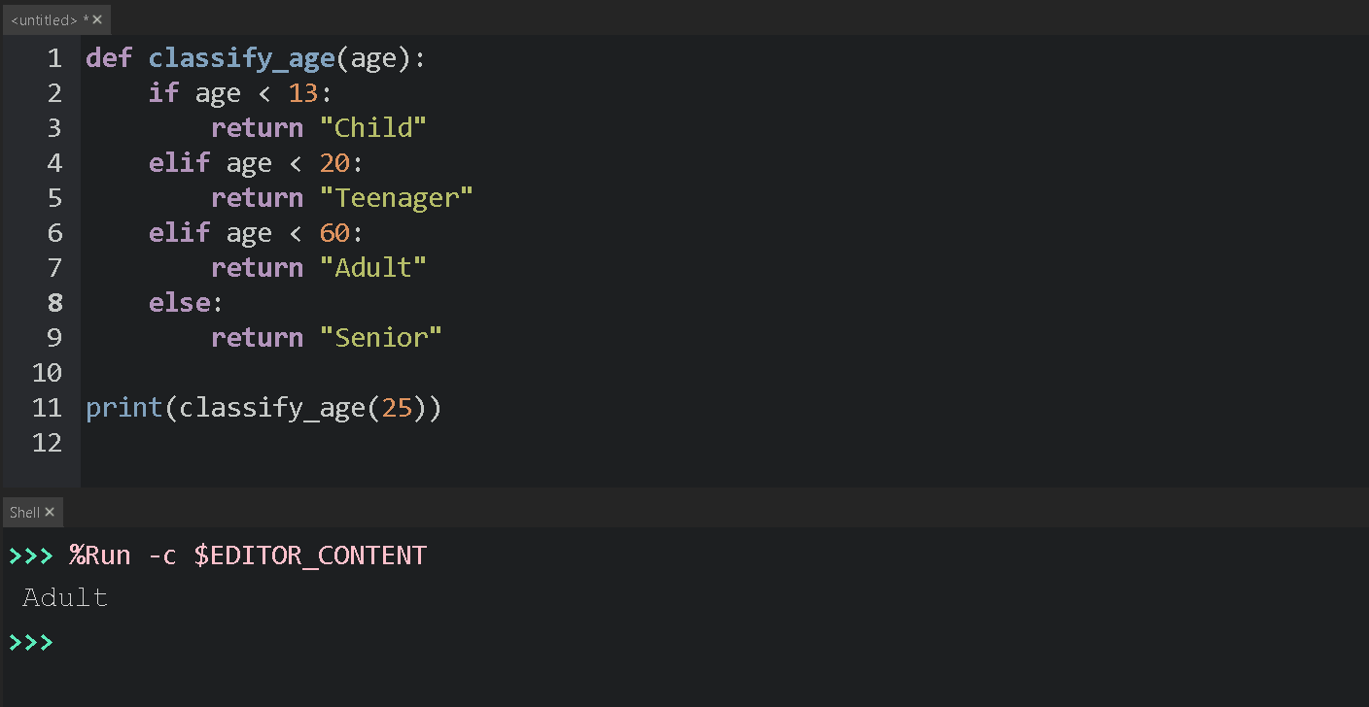

Alternative Approach (Simplified Conditions)
def classify_age_simple(age):
categories = {
range(0, 13): "Child",
range(13, 20): "Teenager",
range(20, 60): "Adult",
range(60, 150): "Senior"
}

for age_range, label in categories.items():
if age in age_range:
return label

Explanation
- if-elif-else is easier for beginners.
- Dictionary-based logic is compact but slightly advanced.
- AI-generated conditions are logically correct and well-ordered.

Task Description #4: For and While Loops (Sum of First n Numbers)
Using a for Loop
def sum_to_n(n):
total = 0
for i in range(1, n + 1):
total += i
return total

print(sum_to_n(10))
Output
55
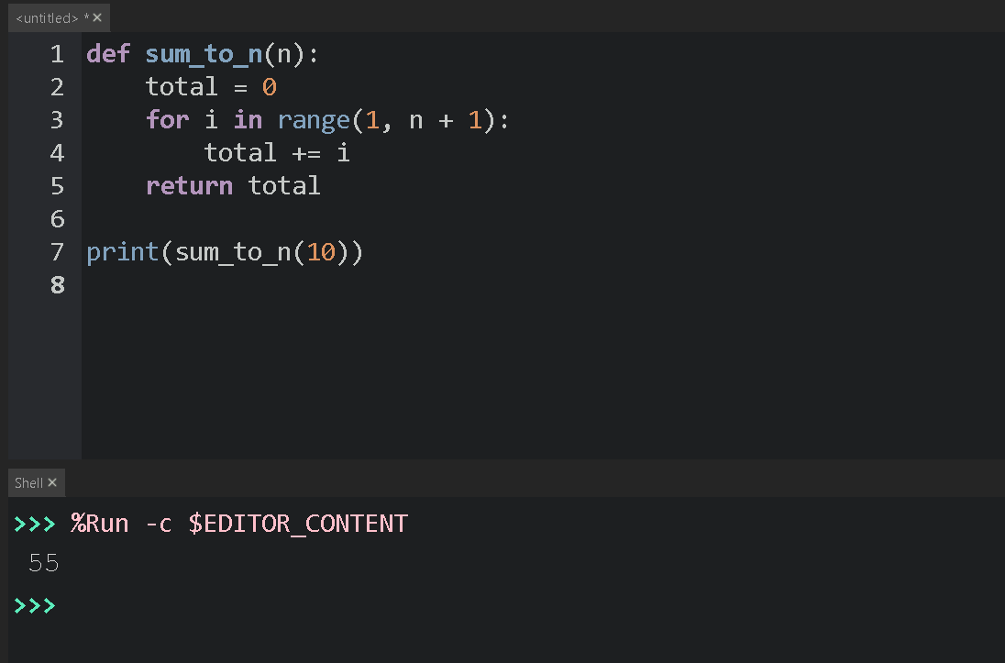

Using a while Loop
def sum_to_n_while(n):
total = 0
i = 1
while i <= n:
total += i
i += 1
return total

Using Mathematical Formula
def sum_to_n_formula(n):
return n * (n + 1) // 2

Comparison
Method | Performance | Complexity
for loop | Good | Easy
while loop | Good | Medium
Formula | Best | Very Simple
AI correctly suggested multiple valid solutions.

Task Description #5: Classes (Bank Account Class)
Scenario
Design a basic banking application.

AI-Generated Bank Account Class
class BankAccount:
def __init__(self, account_holder, balance=0):
self.account_holder = account_holder
self.balance = balance

def deposit(self, amount):
self.balance += amount
print("Deposited:", amount)

def withdraw(self, amount):
if amount <= self.balance:
self.balance -= amount
print("Withdrawn:", amount)
else:
print("Insufficient balance")

def check_balance(self):
print("Current Balance:", self.balance)

# Object creation
account = BankAccount("Preetham", 1000)
account.deposit(500)
account.withdraw(300)
account.check_balance()

Output
Deposited: 500
Withdrawn: 300
Current Balance: 1200
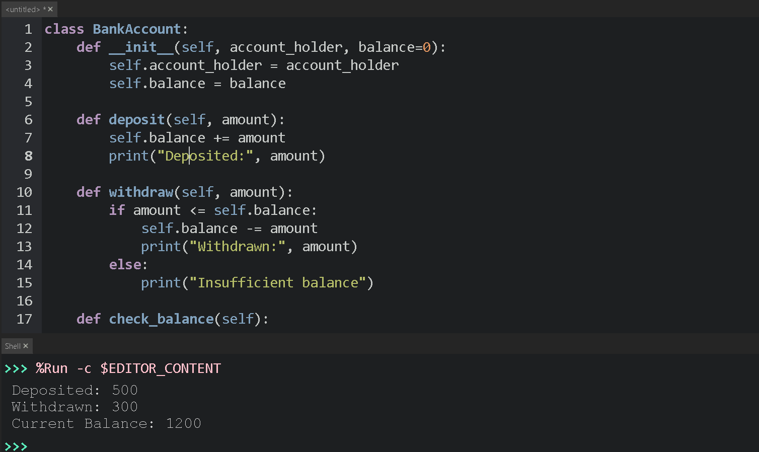

Explanation
- Constructor initializes account holder and balance.
- deposit() increases balance.
- withdraw() checks balance before deducting.
- check_balance() displays current balance.
- AI-generated logic is safe, clear, and realistic.

Overall Conclusion
- AI tools effectively generate Python code for classes, loops, and conditionals.
- Generated code is correct, readable, and efficient.
- Human analysis is still required to ensure clarity, edge-case handling, and optimization.

